|  |
| --- |
| Ambulance Management System |
| DSA Final Term Project |

|  |
| --- |
| Submitted to: Sir Samyan Wahla  By: G43 (2020-CS-10, 2020-CS-19, 2020-CS-34) |

Table of Contents

Project Description: 3

Business Case: 3

End-User: 3

The motivation of the Project: 3

Level of Impact: 3

Wireframes and Use cases: 4

Login Page: 4

Use case: 4

Components: 4

Dashboard(Admin): 5

Use case: 5

Components: 5

Add_Staff(Admin): 6

Use case: 6

Components: 7

View/Update Staff (Admin): 8

Use case: 8

Components: 8

Add Hospital (Admin): 9

Use case: 9

Components: 9

View/Update Hospital (Admin): 10

Use case: 10

Components: 10

View Patient Details (Admin): 11

Use case: 11

Components: 11

Add ambulance (Admin): 11

Use case: 11

Components: 12

View/Update Ambulance (Admin): 12

Use case: 12

Components: 13

View Reports (Admin): 13

Use case: 13

Components: 14

Visualization (Admin): 14

Use case: 14

Components: 15

Dashboard (Staff Member): 15

Use case: 15

Components: 16

Answer to the call (Staff Member): 16

Use case: 16

Components: 17

Assign Ambulance (Staff Member): 17

Use case: 17

Components: 18

Visualization (Staff Member): 18

Use case: 18

Components: 19

View Report (Staff Member): 19

Use case: 19

Components: 20

Provide Info (Caller): 20

Use case: 20

Components: 21

Visualization (Caller): 21

Use case: 21

Components: 22

Data Structures Used: 23

UML Diagram: 23

Ambulance Service Management System

# Project Description:

This project is aimed to develop such a system that manages the ambulance services provided by the healthcare organization. This project will make sure the availability of ambulance services. This system will provide emergency medical services like first aid, ambulances, etc. This system has three types of users Admin, Staff Member, User (Person who calls for an ambulance). Admin can add, view, and update staff member which has different categories like a driver, doctor, caller receiver, etc. Also, the admin can add, view, and update hospitals in any city or specific district. Admin can also view patient details which contain a number of patients brought by ambulances in any specific hospital. Admin can also add, view, and update ambulance. This system will also keep track of the ambulances. When a caller will make a call to call an ambulance, he will be redirected to the page where he will be asked to enter his city name, then in the nearest control room of the Ambulance service his/her details will be entered, and call receiver at the control room will assign an ambulance to the caller. In case, if an Ambulance is not present at that control centre, then that control room will ask for an ambulance to the nearest other control room in that area. After the ambulance will assign, it will start traveling to the caller and will take the patient and will admit them to the nearest hospital. The caller and receiver both will be able to visualize the track of the ambulance. A simple map of cities and ambulances will be shown along there details.

# Business Case:

We are designing this system that will help a citizen who can face any emergency in daily life efficiently. This system will help patients to be treated on the information given at the time of emergency call quickly.

# End-User:

General Public will be the end-user.

# The motivation of the Project:

To help the general public through ambulance services and make the ambulance service system more efficient for a healthcare organization.

# Level of Impact:

This system will help rescue 1122 to recognize staff member (call receiver) performance in case of emergency of a citizen by checking response time of call receiver etc.

# Wireframes and Use cases:

## Login Page:

### Use case:

|  |  |
| --- | --- |
| Use case name | Login page |
| Actor | Admin, Staff Member, Caller |
| Flow of events | ( Username, password, Admin/staff, login ) / call ambulance |

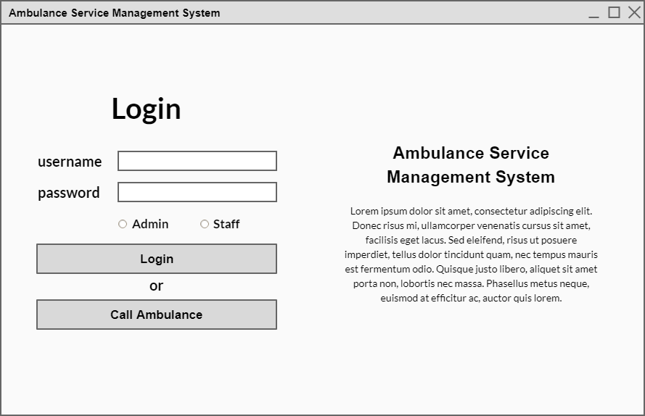

Figure : Login

### Components:

|  |  |  |
| --- | --- | --- |
| UI Component Name | UI Component Type | Description |
| login_label | Label | Label to show text (login). |
| username_input | TextBox | To take input username as text. |
| password_input | TextBox | To take input password as text. |
| admin_rb | RadioButton | To take input either he/she is admin or staff. |
| staff_rb |
| login_btn | Button | To login. |
| description_label | Label | To show description about project. |

## Dashboard(Admin):

### Use case:

|  |  |
| --- | --- |
| Use case name | Admin dashboard |
| Actor | Admin |
| Flow of events | Login as admin 🡪 click on the dashboard button |

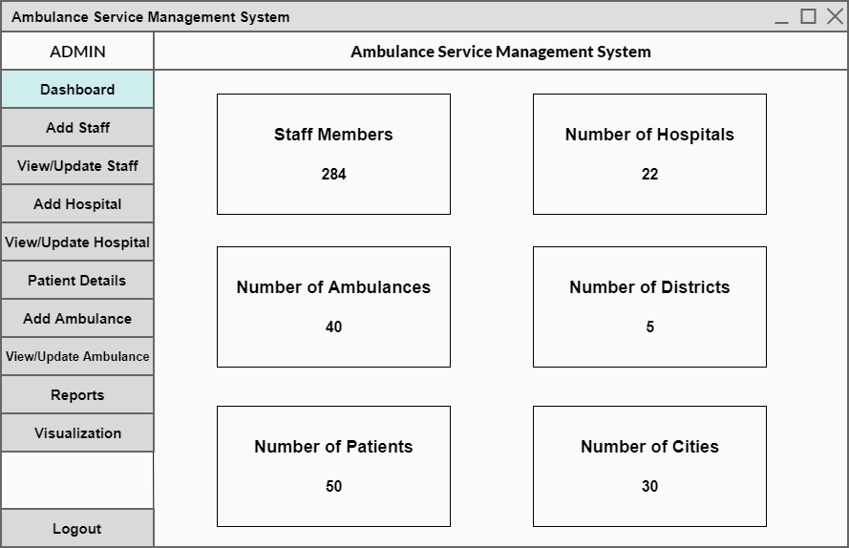

Figure : Dashboard (Admin)

### Components:

|  |  |  |
| --- | --- | --- |
| UI Component Name | UI Component Type | Description |
| admin_label | Label | To show its admin menu. |
| project_name_label | To show project name. |
| dashboard_btn | Button | To show staff members, number of hospitals, ambulances, districts, patients, cities etc. |
| add_staff_btn | To add new staff member. |
| view/update_staff_btn | To view staff member and update any detail. |
| add_hospital_btn | To add hospital in city where hospital is not present. |
| view/update_hospital_btn | To view and update hospital details. |
| patients_details_btn | To show info related to patient. |
| add_ambulance_btn | To add ambulances in parking area. |
| view/update_ambulance_btn | To view and update info related to ambulances. |
| reports_btn | To show reports that belongs patients, ambulances , staff, hospitals etc. |
| visualization_btn | To show track of ambulances between different hospitals. |
| logout_btn | To logout admin from his/her account. |
| staff_members_label | Label | To show number of staff member/hospital/  ambulances/  districts/  patients/  cities. |
| number_of_hospitals_label |
| number_of_ambulances_label |
| number_of_districts_label |
| number_of_patients_label |
| number_of_cities_label |

## Add_Staff(Admin):

### Use case:

|  |  |
| --- | --- |
| Use case name | Add staff page |
| Actor | Admin |
| Flow of events | Login as admin 🡪 click on Add Staff button 🡪 enter name of staff member 🡪 enter id 🡪 select gender 🡪 enter phone number 🡪 select category 🡪 select shift 🡪 select job city 🡪 provide home address 🡪 click on add button |

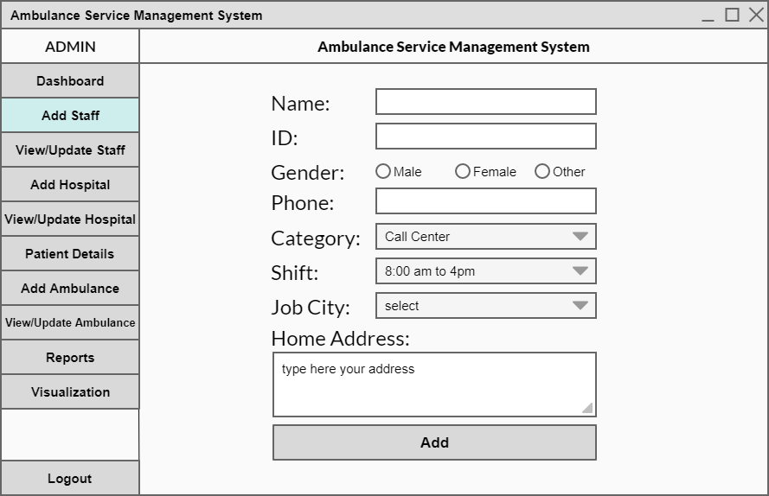

Figure : Add Staff (Admin)

### Components:

|  |  |  |
| --- | --- | --- |
| UI Component Name | UI Component Type | Description |
| add_btn | Button | To add new staff member. |
| name_textbox | TextBox | To enter name of his/her. |
| id_textbox | To enter ID of his/her. |
| phone_textbox | To enter phone number. |
| home_address_textbox | To enter home address of staff member. |
| gender_radio_btn | RadioButton | To check gender. |
| shift_combo_box | ComboBox | To select shift for staff member in which he/she will perform his/her duty. |
| category_combo_box | To select category for staff member. |
| job_city_combo_box | ComboBox | To select city where staff member will be appointed. |

## View/Update Staff (Admin):

### Use case:

|  |  |
| --- | --- |
| Use case name | View/Update staff |
| Actor | Admin |
| Flow of events | Login as admin 🡪 click on view/update staff button 🡪 select category 🡪 click on view button 🡪 select any row 🡪 click on update/delete button |

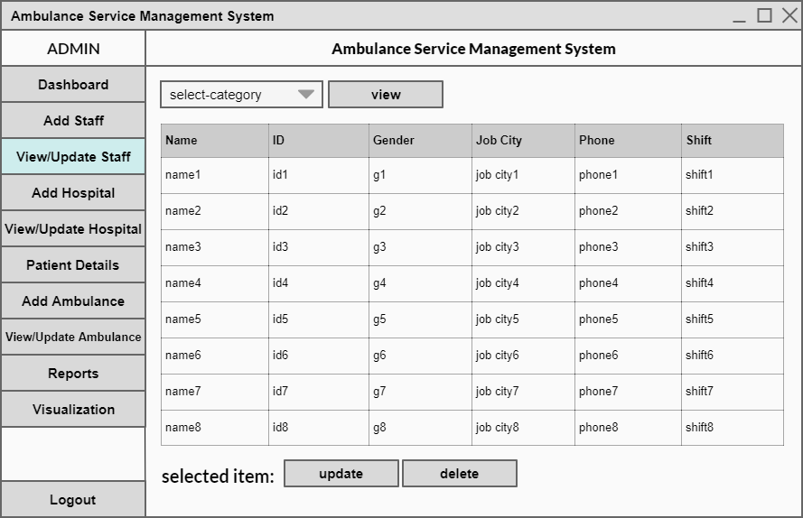

Figure : View/Update Staff (Admin)

### Components:

|  |  |  |
| --- | --- | --- |
| UI Component Name | UI Component Type | Description |
| view_btn | Button | To view/update and delete any staff member. |
| update_btn |
| delete_btn |
| select_category_combo_box | ComboBox | To select any specific category to show data of it. |
| selected_item_label | Label | To show text. |
| staff_table | DataGridView | To display data of staff members. |

## Add Hospital (Admin):

### Use case:

|  |  |
| --- | --- |
| Use case name | Add Hospital |
| Actor | Admin |
| Flow of events | Login as admin 🡪 click on Add Hospital button 🡪 enter the name of hospital 🡪 select city 🡪 enter number of beds 🡪 click on Add button |

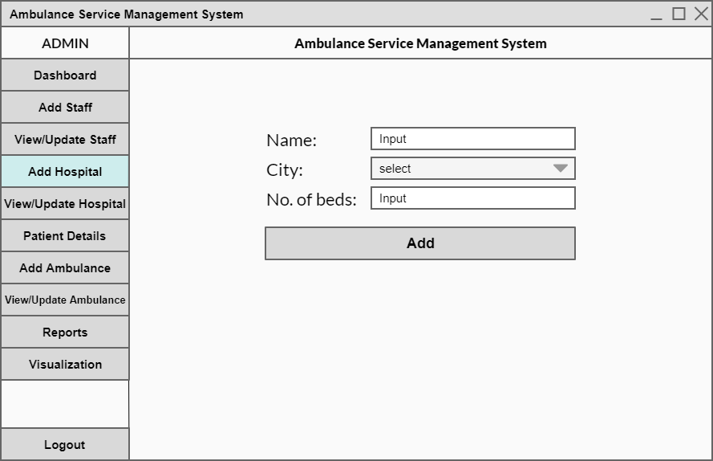

Figure : Add Hospital (Admin)

### Components:

|  |  |  |
| --- | --- | --- |
| UI Component Name | UI Component Type | Description |
| add_btn | Button | To add new hospital in any specific city. |
| name_textbox | TextBox | To enter name of hospital. |
| number_of_beds_textbox | To enter number of beds that hospital will contain. |
| city_combo_box | ComboBox | To select any particular city. |

## View/Update Hospital (Admin):

### Use case:

|  |  |
| --- | --- |
| Use case name | View/Update Hospital |
| Actor | Admin |
| Flow of events | Login as admin 🡪 click on view/update hospital button 🡪 select any row 🡪 click on update/delete button |

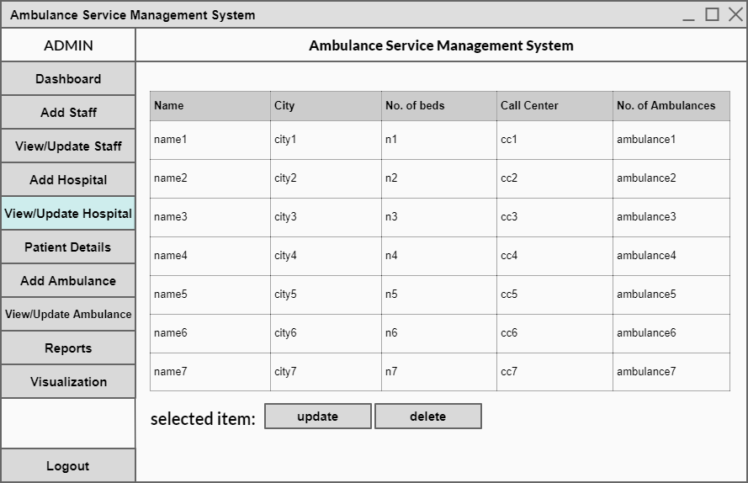

Figure : View/Update Hospital (Admin)

### Components:

|  |  |  |
| --- | --- | --- |
| UI Component Name | UI Component Type | Description |
| update_btn | Button | To update or delete any hospital details. |
| delete_btn |
| selected_item_label | Label | To show text. |
| hospital_table | DataGridView | To show data of hospitals. |

## View Patient Details (Admin):

### Use case:

|  |  |
| --- | --- |
| Use case name | View patient details |
| Actor | Admin |
| Flow of events | Login as admin 🡪 click on patient details |

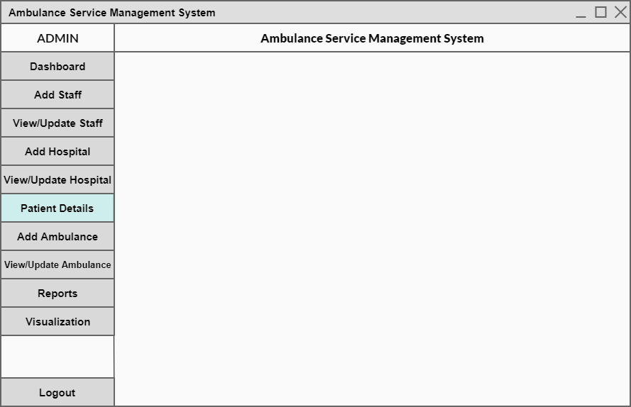

Here table will be show to view the patents

Figure : View Patient Details (Admin)

### Components:

|  |  |  |
| --- | --- | --- |
| UI Component Name | UI Component Type | Description |
| patients_table | DataGridView | To show data of patients admitted/discharged, disease etc. |

## Add ambulance (Admin):

### Use case:

|  |  |
| --- | --- |
| Use case name | Add ambulance |
| Actor | Admin |
| Flow of events | Login as admin 🡪 click on add ambulance button 🡪 enter ID 🡪 Enter engine number 🡪 select hospital 🡪 provide purchase date 🡪 click on Add button |

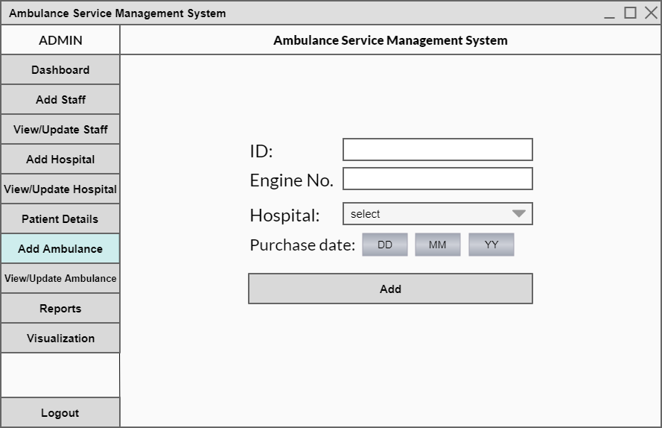

Figure : Add ambulance (Admin)

### Components:

|  |  |  |
| --- | --- | --- |
| UI Component Name | UI Component Type | Description |
| add_btn | Button | To add new ambulance to any specific hospital. |
| id_textbox | TextBox | To enter ambulance ID. |
| engine_no_textbox | To enter ambulance engine number. |
| hospital_combo_box | ComboBox | To select any specific hospital in which ambulance will be added. |
| date_input_label | Label | To show text. |
| date_input_picker | DateTimePicker | To select date of purchase of ambulance. |

## View/Update Ambulance (Admin):

### Use case:

|  |  |
| --- | --- |
| Use case name | View/Update Ambulance |
| Actor | Admin |
| Flow of events | Login as admin 🡪 click on view/update button |

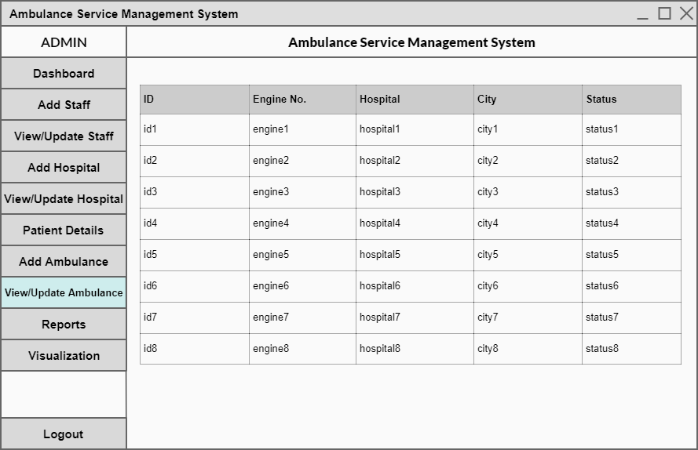

Figure : View/Update Ambulance (Admin)

### Components:

|  |  |  |
| --- | --- | --- |
| UI Component Name | UI Component Type | Description |
| ambulance_table | DataGridView | To show data that belongs to ambulances. |

## View Reports (Admin):

### Use case:

|  |  |
| --- | --- |
| Use case name | View reports |
| Actor | Admin |
| Flow of events | Login as admin 🡪 click on reports button 🡪 select start date 🡪 select end date 🡪 select category/type 🡪 click Generate Report button |

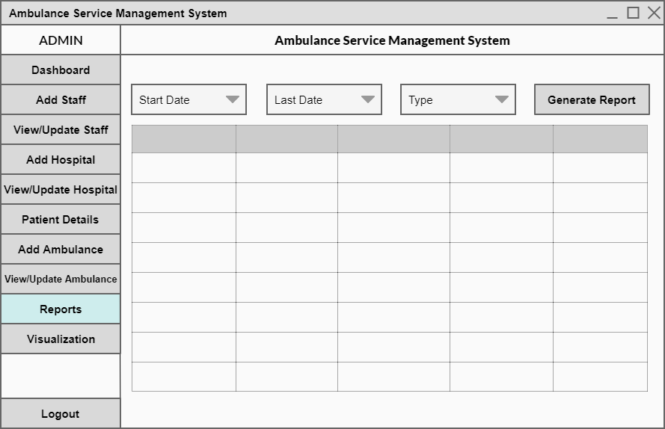

Figure : View Reports (Admin)

### Components:

|  |  |  |
| --- | --- | --- |
| UI Component Name | UI Component Type | Description |
| reports_table | DataGridView | To show reports of patients, ambulances, hospitals, staff etc. Within specific dates. |
| generate_report_btn | Button | To show data according to dates selected above. |
| start_date_combo_box | ComboBox | To select starting/ending date and type. |
| last_date_combo_box |
| type_combo_box |

## Visualization (Admin):

### Use case:

|  |  |
| --- | --- |
| Use case name | Visualization |
| Actor | Admin |
| Flow of events | Login as admin 🡪 click on visualization |

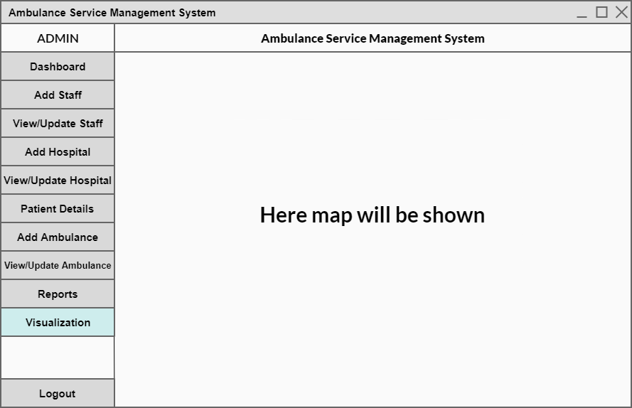

Figure : Visualization (Admin)

### Components:

|  |  |  |
| --- | --- | --- |
| UI Component Name | UI Component Type | Description |
| map_picturebox | PictureBox | To show map that contains cities and the ambulances that where is ambulance going and in which direction. |
| city_picturebox |
| ambulance_picturebox |

## Dashboard (Staff Member):

### Use case:

|  |  |
| --- | --- |
| Use case name | Dashboard |
| Actor | Staff Member |
| Flow of events | Log in as a staff member 🡪 click on the Dashboard button |

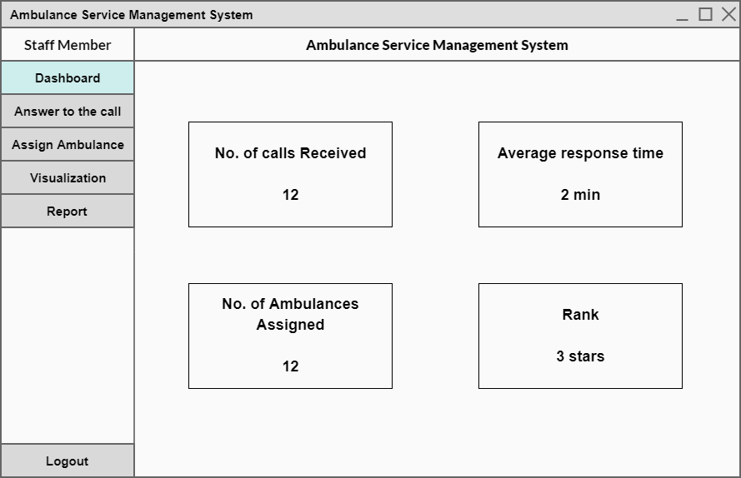

Figure : Dashboard (Staff Member)

### Components:

|  |  |  |
| --- | --- | --- |
| UI Component Name | UI Component Type | Description |
| calls_received_label | Label | To show text about number of calls received/average response time/ambulances assigned/rank etc. |
| average_response_time_label |
| ambulances_assign_label |
| rank_label |

## Answer to the call (Staff Member):

### Use case:

|  |  |
| --- | --- |
| Use case name | Answer to the call |
| Actor | Staff Member |
| Flow of events | Log in as a staff member 🡪 click on the Answer to the call button 🡪 click on receive button |

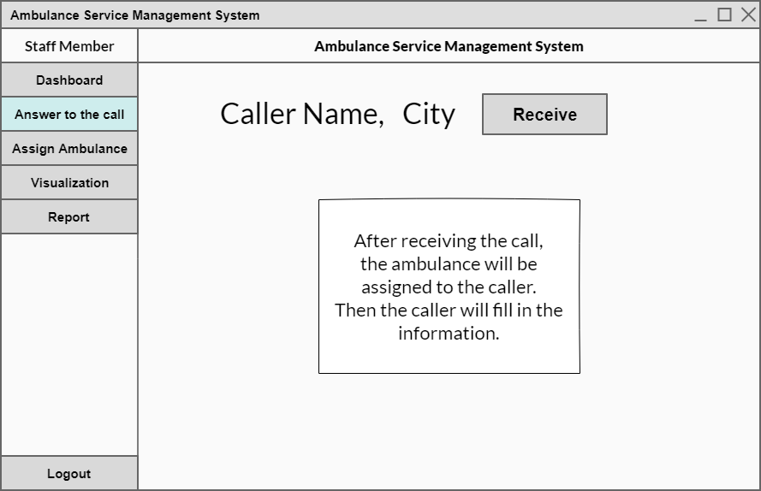

Figure : Answer to the call (Staff Member)

### Components:

|  |  |  |
| --- | --- | --- |
| UI Component Name | UI Component Type | Description |
| city_label | Label | To show text about name of city and caller name. |
| caller_name_label |
| receive_btn | Button | To receive emergency call from citizens. |

## Assign Ambulance (Staff Member):

### Use case:

|  |  |
| --- | --- |
| Use case name | Assign Ambulance |
| Actor | Staff Member |
| Flow of events | Log in as a staff member 🡪 click on the Assign Ambulance button 🡪 click on the assign button |

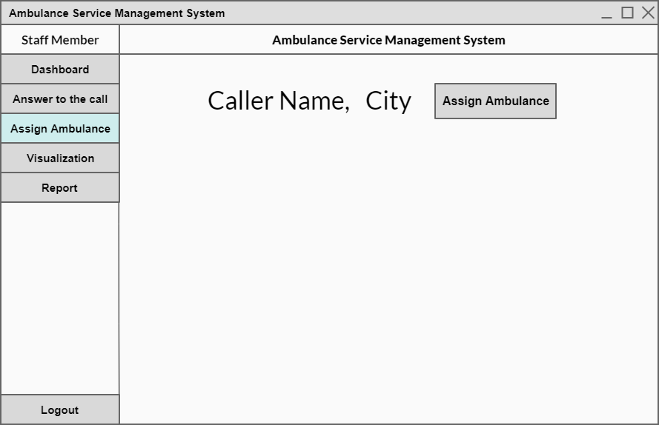

Figure : Assign Ambulance (Staff Member)

### Components:

|  |  |  |
| --- | --- | --- |
| UI Component Name | UI Component Type | Description |
| city_label | Label | To show text about name of city and caller name. |
| caller_name_label |
| assign_btn | Button | To assign ambulance to that person. |

## Visualization (Staff Member):

### Use case:

|  |  |
| --- | --- |
| Use case name | Visualization |
| Actor | Staff Member |
| Flow of events | Log in as a staff member 🡪 click on the Visualization button |

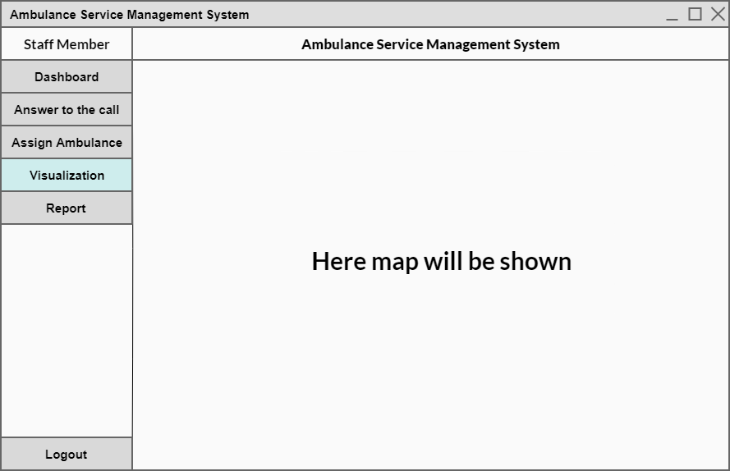

Figure : Visualization (Staff Member)

## Components:

|  |  |  |
| --- | --- | --- |
| UI Component Name | UI Component Type | Description |
| map_picturebox | PictureBox | To show map that contains cities and the ambulances that where is ambulance going and in which direction. |
| city_picturebox |
| ambulance_picturebox |

## View Report (Staff Member):

### Use case:

|  |  |
| --- | --- |
| Use case name | View Report |
| Actor | Staff Member |
| Flow of events | Log in as a staff member 🡪 click on the view report button 🡪 select the start date 🡪 then select the end date 🡪 select the type 🡪 click on the Generate Report button |

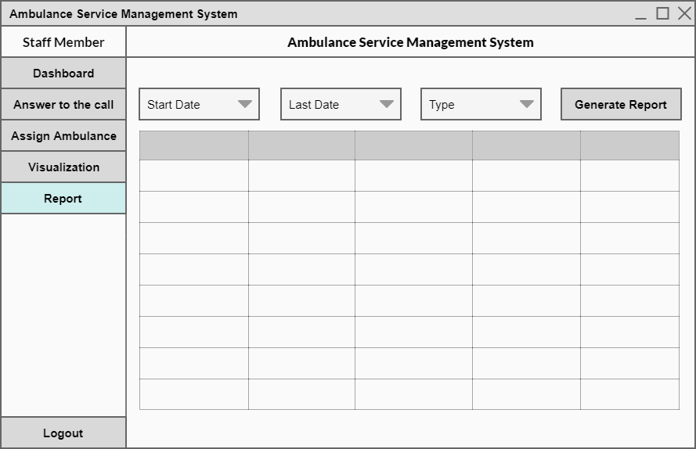

Figure : View Report (Staff Member)

### Components:

|  |  |  |
| --- | --- | --- |
| UI Component Name | UI Component Type | Description |
| reports_table | DataGridView | To show reports of patients, ambulances, hospitals, staff etc. Within specific dates. |
| generate_report_btn | Button | To show data according to dates selected above. |
| start_date_combo_box | ComboBox | To select starting/ending date and type. |
| last_date_combo_box |
| type_combo_box |

## Provide Info (Caller):

### Use case:

|  |  |
| --- | --- |
| Use case name | Provide info |
| Actor | Caller |
| Flow of events | Click on the Call Ambulance button 🡪 click on the Provide info button 🡪 enter your name 🡪 select city 🡪 click on the Call button |

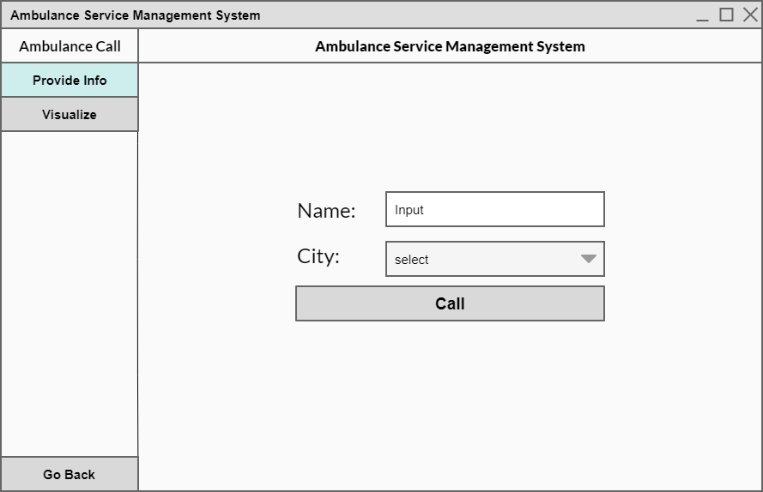

Figure : Provide Info (Caller)

### Components:

|  |  |  |
| --- | --- | --- |
| UI Component Name | UI Component Type | Description |
| city_combo_box | ComboBox | To select any city. |
| call_btn | Button | To call for rescue. |
| name_textbox | TextBox | To enter name. |

## Visualization (Caller):

### Use case:

|  |  |
| --- | --- |
| Use case name | Visualization |
| Actor | Caller |
| Flow of events | Click on the Call Ambulance button 🡪 click on visualize 🡪 enter patient name 🡪 enter CNIC number 🡪 enter your age 🡪 select your gender 🡪 click on submit button |

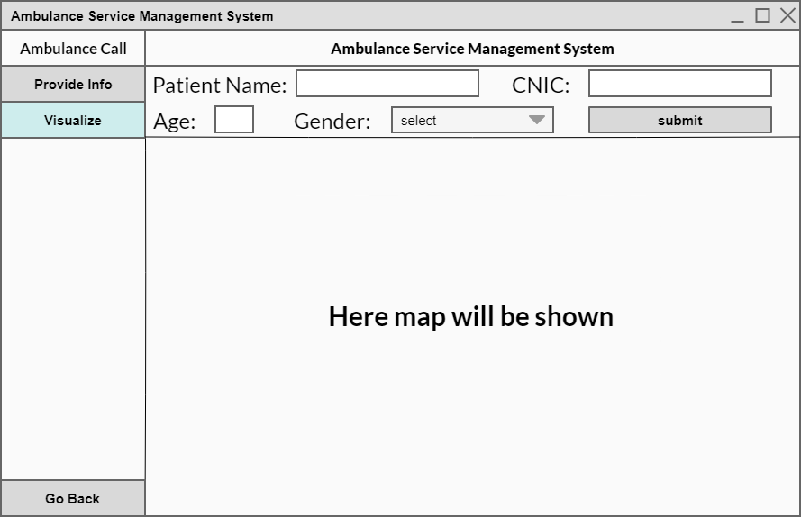

Figure : Visualization (Caller)

### Components:

|  |  |  |
| --- | --- | --- |
| UI Component Name | UI Component Type | Description |
| map_picturebox | PictureBox | To show map that contains cities and the ambulances that where is ambulance going and in which direction. |
| city_picturebox |
| ambulance_picturebox |
| patient_name_textbox | TextBox | To enter patient name. |
| cnic_textbox | To enter cnic of patient. |
| age_textbox | To enter age of patient. |
| submit_btn | Button | To submit the details of patient. |
| gender_combo_box | ComboBox | To select gender type. |

# Data Structures Used:

|  |  |
| --- | --- |
| **Data Structure** | **Description** |
| Linked list | Staff, drivers, patients |
| Stack | Ambulance parking, call receive |
| Graph | Visualization ( a map will be shown to visualize the cities and tracks of ambulances between different cities ) |
| Array | Cities ( Fixed number ) |

# UML Diagram:

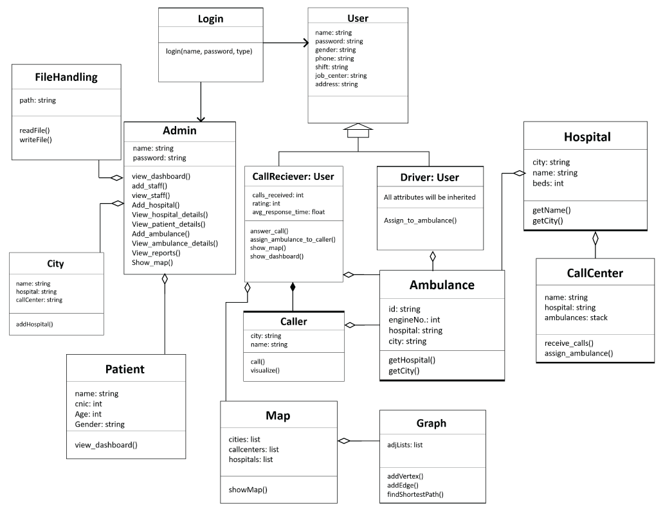

Figure : UML Diagram